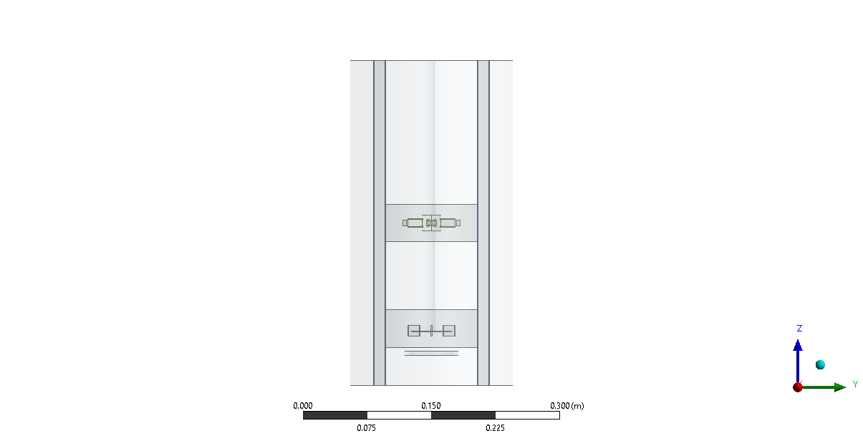

**CFD Investigation of Hydrodynamics in a Stirred Tank Reactor with Dual Impellers**

Kasina Bhaskar1, Roushni Kumari1, Raghvendra Gupta1,2,3, Rajesh K. Upadhyay4

1Department of Chemical Engineering, IIT Guwahati, India

2Centre for Sustainable Polymers, IIT Guwahati

3Jyoti and Bhupat Mehta School of Health Sciences and Technology, IIT Guwahati

4Department of Chemical Engineering and Technology IIT (BHU), Varanasi

**Student Academic Board (SAB), Indian Institute of Technology Guwahati, Guwahati, Assam, India**

*Corresponding Author: kasinabhaskar@iitg.ac.in

**Research & Industrial Conclave 2023 "An amalgamation of Academia, Industry & Start-up”**

**"**

**Abstract**

Stirred tank reactors (STR) are widely used in chemical and biochemical industries for mixing, homogenization, and chemical reactions. In this study, we present a 3D computational fluid dynamics (CFD) investigation into the hydrodynamics of a stirred tank reactor with dual impellers as shown in Fig.1. The impellers used in the study include a conventional Rushton turbine and a novel impeller with an aspect ratio of 2 and a unique flow pattern. The simulations were carried out using ANSYS 19.2, a commercial CFD software, with the Euler-Euler (E-E) method and the standard k-epsilon turbulence model, with the Grace drag model and the Brucato drag modification. Multiple reference frame (MRF) method is used to model the impeller rotation. Two MRF regions were created for each impeller. Relative velocity formulation is used to calculate the velocity in between the zones. The simulations were carried out with a superficial gas velocity of 4 mm/s and a bubble diameter of 4 mm. The two-phase velocity and air volume fraction plots were generated for further analysis, along with velocity vector plots for understanding the flow behavior and flow pattern.

**Keywords:** Computational Fluid Dynamics, Multiple Reference Frame, Stirred Tank Reactor, Euler-Euler

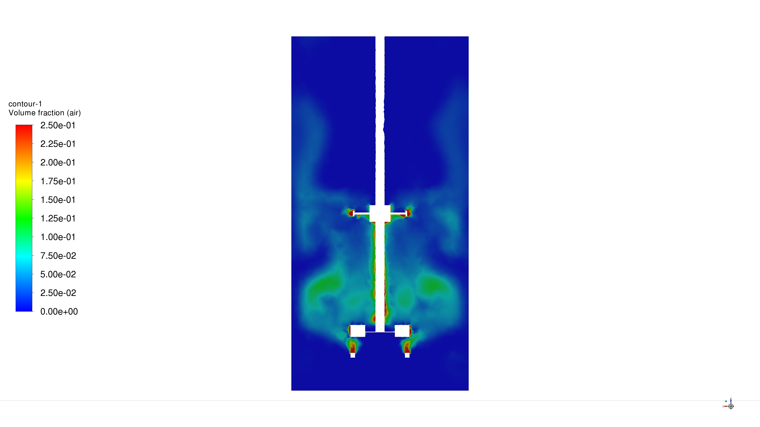 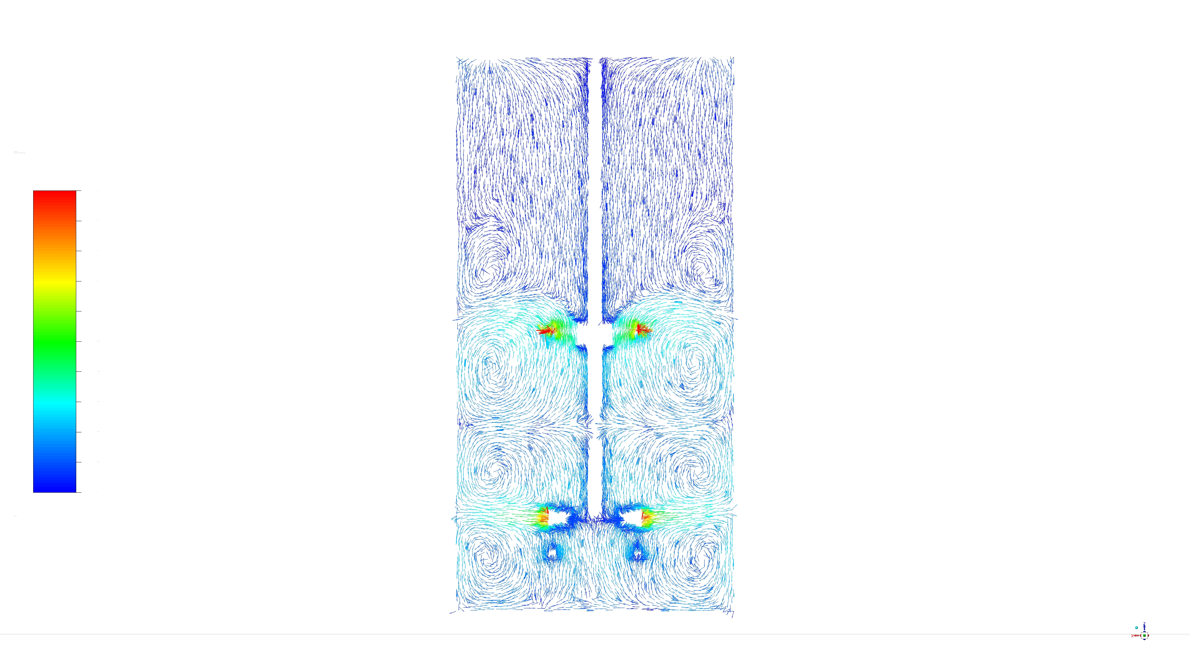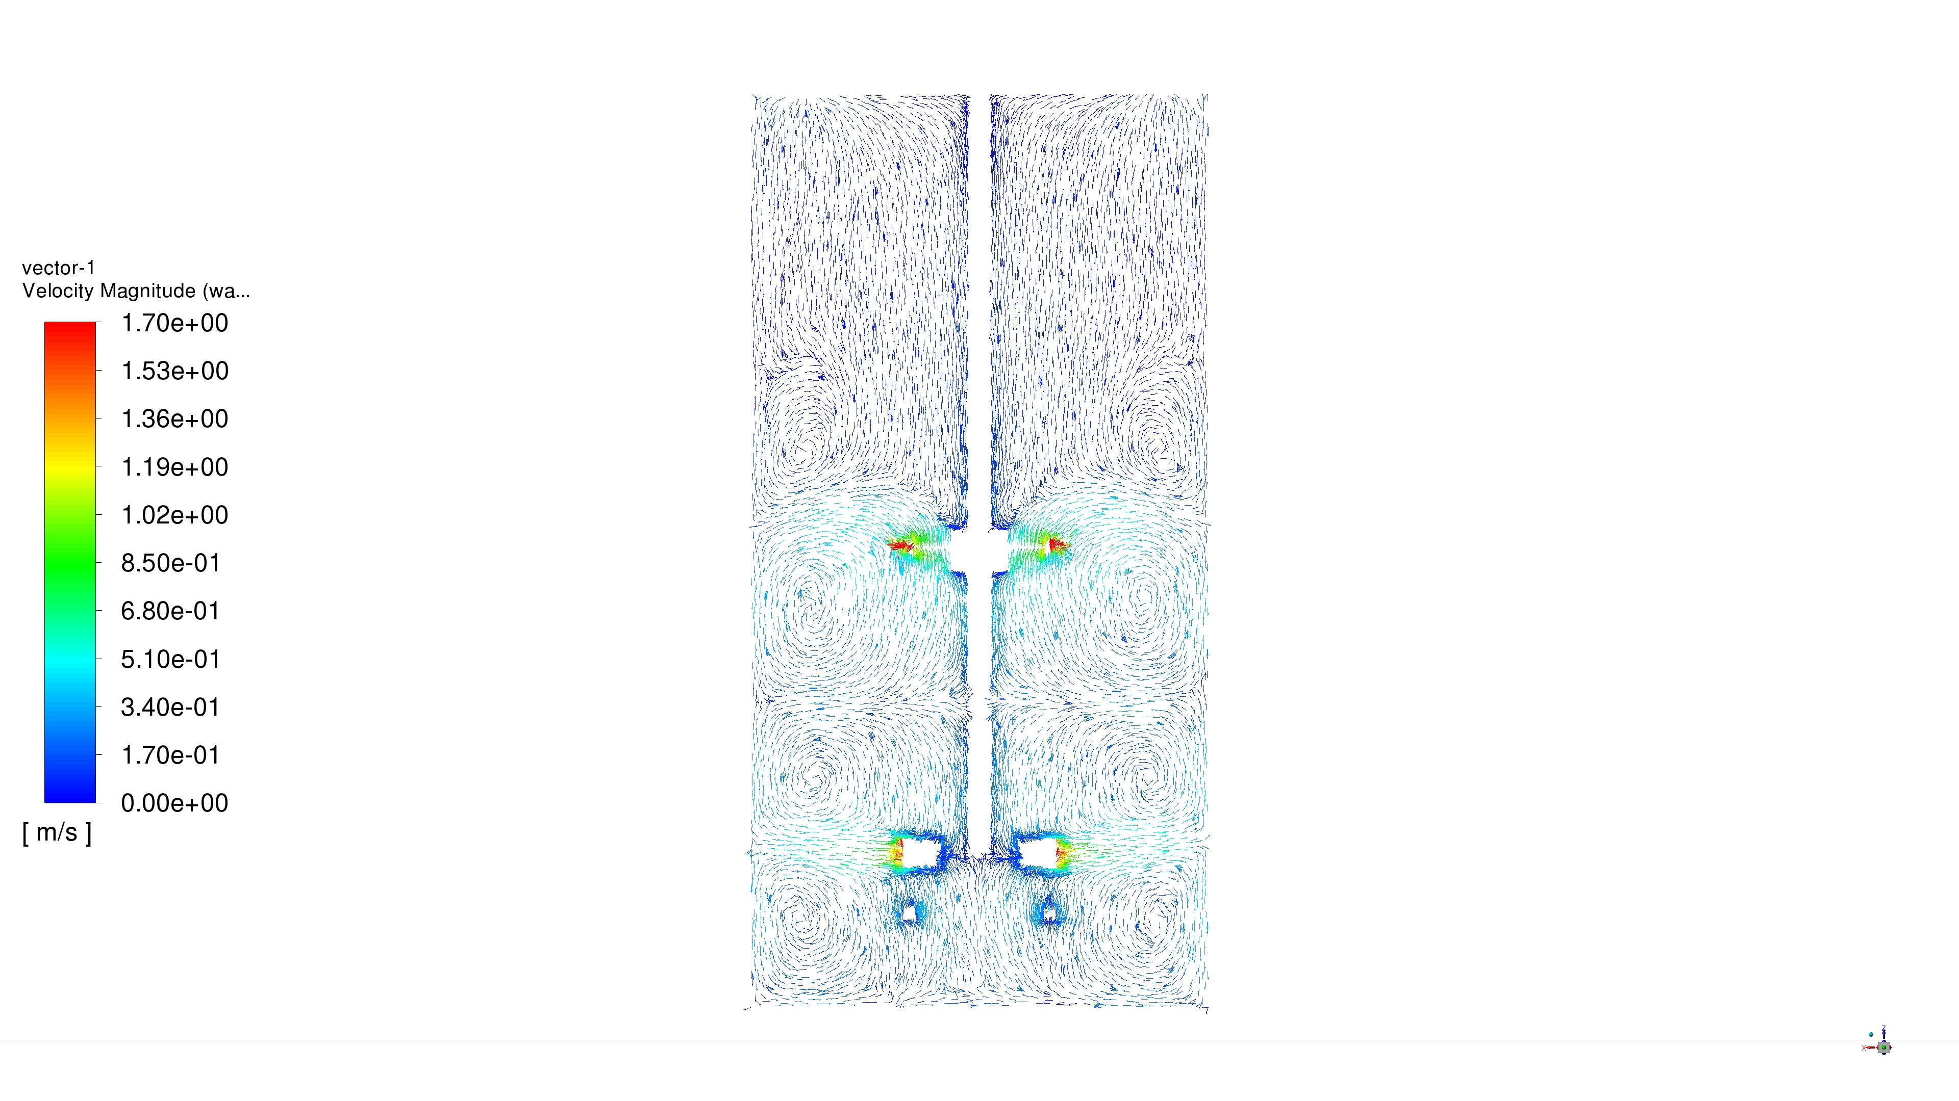

1. (b)

Figure1. (a) Air volume fraction plot (b) Water velocity magnitude vector plot

At t = 2.17 s for N = 500 rpm and Vsg = 4mm/s